Semester 1 2022

ATAR course examination

Question/Answer booklet

**Year 11 ATAR COMPUTER SCIENCE AECSC**

Surname:

Other names:

WA student number (if known)

SIDE Teacher:

SIDE Student Coordinator:

**Supervisor’s declaration**

I declare that this examination paper has been completed by the student named above. The time and resource restrictions have been observed and the student has NOT accessed notes, texts, reference books, the internet, a computer, a calculator or a mobile phone unless otherwise specified. I understand that breaches of the examination rules could lead to an examination paper being cancelled or having an examination mark significantly lowered.

Supervisor’s name:

Signature: Date:

**Time allowed for this paper**

Reading time before commencing work: ten minutes

Working time: two and a half hours

**Materials required/recommended for this paper**

***To be provided by the supervisor***

This Question/Answer booklet

***To be provided by the candidate***

Standard items: pens (blue/black preferred), pencils (including coloured), sharpener, correction fluid/tape, eraser, ruler, highlighters

Special items: up to three calculators, which do not have the capacity to create or store programmes or text, are permitted in this ATAR course examination, Mathomat and/or Mathaid and/or any system flowchart template

**Important note to candidates**

No other items may be taken into the examination room. It is **your** responsibility to ensure that you do not have unauthorised material. If you have any unauthorised material with you, hand it to the supervisor **before** reading any further.

**Structure of this paper**

|  |  |  |  |  |  |
| --- | --- | --- | --- | --- | --- |
| Section | Number of questions available | Number of questions to be answered | Suggested working time (minutes) | Marks available | Percentage of examination |
| Section One:  Short answer | 20 | 20 | 60 | 112 | 40 |
| Section Two:  Extended answer | 5 | 5 | 90 | 93 | 60 |
|  |  |  |  | **Total** | 100 |

**Instructions to candidates**

1. The rules for the conduct of Western Australian external examinations are detailed in the *Year 12 Information Handbook 2022*. Sitting this examination implies that you agree to abide by these rules.

2. Write your answers in the spaces provided in this Question/Answer Booklet. A blue or black ballpoint or ink pen should be used. Wherever appropriate, fully labelled diagrams, tables and examples should be used to illustrate and support your answers.

3. You must be careful to confine your responses to the specific questions asked and to follow any instructions that are specific to a particular question. Where no specific instructions are given, you should feel free to use a range of formats to express your knowledge and understandings.

4. Spare pages are included at the end of this booklet. They can be used for planning your responses and/or as additional space if required to continue an answer.

* Planning: If you use the spare pages for planning, indicate this clearly at the top of the page.
  + Continuing an answer: If you need to use the space to continue an answer, indicate in the original answer space where the answer is continued, i.e. give the page number. Fill in the number of the question(s) that you are continuing to answer at the top of the page.

**Section 1: Short Answer 40% (112 Marks)**

This section contains **20** questions. You must answer **all** questions. Write your answers in the spaces provided.

Spare pages are included at the end of this booklet. They can be used for planning your responses and/or as additional space if required to continue to answer.

* Planning: If you use the spare pages for planning, indicate this clearly at the top of the page.
* Continuing an answer: If you need to use the space to continue an answer, indicate in the original answer space where the answer is continued, i.e. give the page number. Fill in the number of the question that you are continuing to answer at the top of the page.

Suggested working time: 60 minutes.

**Question 1 (4 marks)**

Discuss the differences between a linear methodology (SDLC) in Project Management and a non-linear or iterative approach (Prototyping).

**Question 2 (1 mark)**

In what stage of the System Development Life Cycle does the acquisition of hardware occur?

**Question 3 (13 marks)**

In the table below, draw a line between the document and the stage in the SDLC in which it would occur. Some may occur in more than one stage.

|  |  |  |
| --- | --- | --- |
| Use of CASE tool |  | Preliminary Analysis |
| Context Diagram |  |
| Testing plan |  | Analysis |
| User requirements |  |
| Training plan |  | Design |
| Driver updates schedule |  |
| End User surveys |  | Development |
| Entity Relationship Diagram |  |
| User Interview notes |  | Implementation |
| Data Flow diagrams |  |
| Economic feasibility report |  | Evaluation |
| Document analysis |  |
| Problem statement |  | Maintenance |
|  |  |

**Question 4 (2 marks)**

In databases what is an Attribute? Give an example of something that could be an attribute.

**Question 5 (8 marks)**

Complete the following table in relation to secondary storage options.

|  |  |  |
| --- | --- | --- |
| **Storage** | **Solid State Drive** | **Hard Drive** |
| **Advantage 1** |  |  |
| **Advantage 2** |  |  |
| **Disadvantage 1** |  |  |
| **Disadvantage 2** |  |  |

**Question 6 (8 marks)**

Discuss the following components by identifying their function with a system and their impact on system performance. (2 marks each)

CPU Cores:

Clock Speed:

Control Bus:

\

RAM:

**Question 7 (2 marks)**

Give an example of utility software and state what your example does.

**Question 8 (16 marks)**

1. In project management explain what scheduling and tracking are and how one might change based on the other. (6 Marks)

1. Explain the two main approaches to establishing the budget for a project and give an advantage and disadvantage for each. (6 Marks)

1. In a budget what are direct and indirect costs? Give an example of each. (4 Marks)

**Question 9 (2 marks)**

Discuss why training requirements would influence the choice of hardware or software to be purchased.

**Question 10 (2 marks)**

Discuss how you determine if changing over to a new system has been successful.

**Question 11 (8 marks)**

Discuss why the following diagrams are incorrect (2 marks each).

b)

c)

**Question 12 (6 marks)**

Discuss how private/private and public/private key encryption works and why one method is more secure.

**Question 13 (6 marks)**

1. Explain why this ERD will cause issues within a database if it is left unresolved (2 marks)

Product

Supplier

Supplies

M

M

1. How is the above diagram resolved? Illustrate below. (4 marks)

**Question 14 (3 marks)**

Give three methods that can be used to implement authentication to protect against unauthorised access to data in a database.

**Question 15 (8 marks)**

What is meant by the following database terms?

Atomicity:

Data Integrity:

Data redundancy:

Data field:

Data record:

Primary key:

Foreign key:

**Question 16 (3 marks)**

Discuss what is meant by the hierarchical structure of data. Use examples to illustrate your answer.

**Question 17 (8 marks)**

Discuss troubleshooting strategies for the following situations.

**Scenario 1:** An application is running slowly. (2 marks)

1. What would be your first step?

1. You have tried (a) and the application is still running slowly.

**Scenario 2:** An application has frozen. (2 marks)

1. What would be your first step?

1. You have tried (c) and the application is still frozen.

**Scenario 3:** Your monitor has no image (3 marks)

1. What would be your first step?

1. You have tried (e) and it is still no image.

1. You have tried (e) and (f) and the computer is still no image.

**Scenario 4:** Your keyboard and mouse are not communicating with the computer. (1 mark)

1. What is the first thing you should check?

Questions 18 – 19 refers to the following scenario

Dr Lois has set up a Medical Practice in Perth and is installing a highly recommended online database to store their patients data. The database software has been developed by SecureOnlineData Pty Ltd. Their company and host server are based in the United Kingdom. They will manage and secure all her data for a monthly fee.

**Question 18**

Discuss the benefits of using an online software solution in this situation. **(3 marks)**

**Question 19 (4 marks)**

1. Identify a potential privacy issue in this scenario referring to Australia’s 1988 Privacy Act. (2 marks)

1. Discuss a potential ethical issue with the storage of data in this scenario. (2 marks)

**Question 20 (5 marks)**

Discuss the concept of a boot process within a system by identifying the sequence of steps taken from when the power is turned on.

End of Section One

**Section Two: Extended answer 60% (93 Marks)**

This section has **five (5)** questions. Answer **all** questions. Write your answers in the spaces provided.

Spare pages are included at the end of this booklet. They can be used for planning your responses and/or as additional space if required to continue to answer.

* Planning: If you use the spare pages for planning, indicate this clearly at the top of the page.
* Continuing an answer: If you need to use the space to continue an answer, indicate in the original answer space where the answer is continued, i.e. give the page number. Fill in the number of the question that you are continuing to answer at the top of the page.

Suggested working time: 90 minutes.

Benjamin is a qualified chef. He no longer wanted to work in commercial kitchens so established himself as a Chef for Hire. He called his business Cheffies.

He has chosen to concentrate on home dinner parties that can be full sit-down meals or be turned into cooking lessons. Benjamin’s business has grown, and his previous spreadsheets are no longer keeping track of his clients, expenses, stock or profit efficiently nor effectively. In addition, he has taken on other chefs who enable him to have some nights off from work.

He has asked a friend of his who has a student in Year 12 Computer Science to design a new system for him that will allow better monitoring of his business.

It has been established that:

* Cheffies advertises on Facebook. He pays $0.95 per click which is invoiced weekly by Facebook. Benjamin pays as soon as the invoice from Facebook arrives.
* He also has a Facebook page with current clients as friends. Clients must request to join his page and private message him their personal details.
* Once they are registered as his friend, Benjamin will then respond to their requests for quotes.
* Benjamin offers a variety of packages. A client will choose the dinner/lesson package they want from a list pinned to Benjamin’s computer. A price will be quoted from the list price per person on the package.
* Benjamin writes up a quote and emails it to them. If the client accepts, Benjamin will send them a formalised invoice. To book, clients must provide a 20% deposit as well as booking details including address, date, and time of the booking. Benjamin stores his invoices on a spike and enters the booking details into a spreadsheet.
* The balance of the invoice is payable three days after the function. Once paid, Benjamin removes the invoices from the spike and places then in a paid invoices file.
* Benjamin orders stock from a variety of suppliers including supermarkets and specialist butchers. He places the order over the internet and enters the details in a spreadsheet. He will then collect the delivery and checks it against the supplied invoice and the order. The balance of the invoice is paid at the end of the week. He needs to store his purchase invoices so places them in the top drawer of his desk.
* When the delivery of supplies arrives, Benjamin updates his stores with the products.

**Question 21 (8 marks)**

1. Justify which project management methodology Cheffies should use to introduce a new system into the workplace. (5 marks)

1. As part of the new system, all of Cheffies employees will be asked to email Benjamin the food items they have taken from the storage facility. One of his new staff members sent an email around to all staff that contained an inappopriate meme they found amusing and wanted to share.

This same staff member also shared their password with their 17 year old child allowed them to access the laptop provided by Cheffies for games.

Benjamin has concerns about the sensitivity of the data contained in the database as well as the offense caused by the inappropriate meme.

Discuss ways in which Benjamin can help minimise incidents like these arising.

(3 marks)

**Question 22 (16 marks)**

Referring to the scenario presented, create a Context Diagram for Cheffies system below.

**Question 23 (30 marks)**

Create a DFD Level 0 for the Cheffies system below.

**The following Figures are will be used for Questions 24 and 25**

**Figure 1 (Below)**

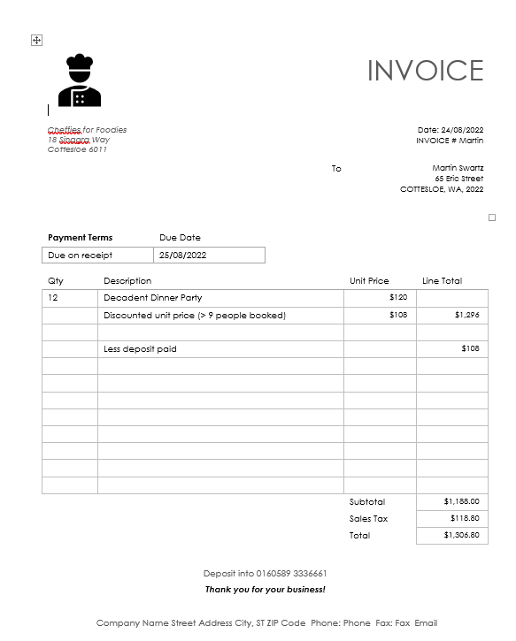**Figure 2 (Below)**

**Figure 3 (Below)**

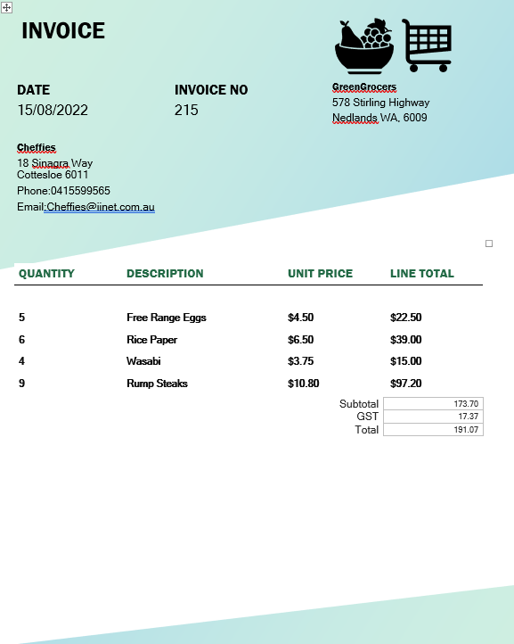

**Question 24 (15 marks)**

Refer to the table on page 20 (Figure 1) to answer the following questions.

All bookings require a Deposit which is 20% of the Total.

1. Write the formula likely to be contained in the Deposit column (I2:I6)? (4 marks)

1. Column ‘Cost Per Person F2:F6 refers to the table data located in A16:C21. Write the formula likely to be contained in the ‘Cost Per person’ column. (5 marks)

1. Justify why a relational database may be more suitable for Benjamin than the flat file database he is currently using by discussing advantages and disadvantages of each.

(6 marks)

**Question 25 (24 marks)**

Benjamin is developing a product sheet for each of his dinner/class packages. This allows him to track costs to each of his packages and monitor stock levels in his supplies store.

Create an Entity Relationship Diagram that represents the data in the table (Figure 1) and the two invoices (Figure 2 and 3). Part of the diagram has been created for you.

You must identify cardinality, primary and foreign keys using Chen’s notation.

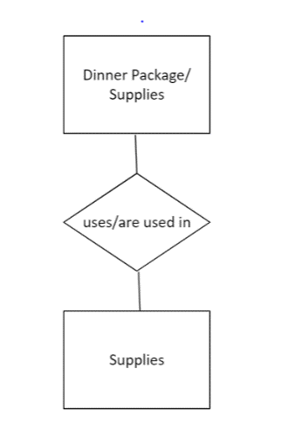

End of questions

Question No:

Question No:

Question No: